

|  |  |
| --- | --- |
| **Student Name/ID Number:** | Muhammad kemal / BDSE07-0922-084 |
| **Academic Year:** | 2023 |
| **Unit Assessor:** | Ei Thandar Khaing |
| **Project Title:** | Power BI Data Preparation and Data Transformation |
| **Issue Date:** | 09-Dec-2023 |
| **Submission Date:** | 17-Dec-2023 |

|  |
| --- |
| **Learner declaration** |
| I certify that the work submitted for this assignment is my own and research sources are fully acknowledged.      Student signature:  Date: 17-01-2023 |

**Assignment 6:**

Assignment on Power BI data transformation and data modeling using a different dataset:

1. Import the "Employee Information" dataset in Power BI.

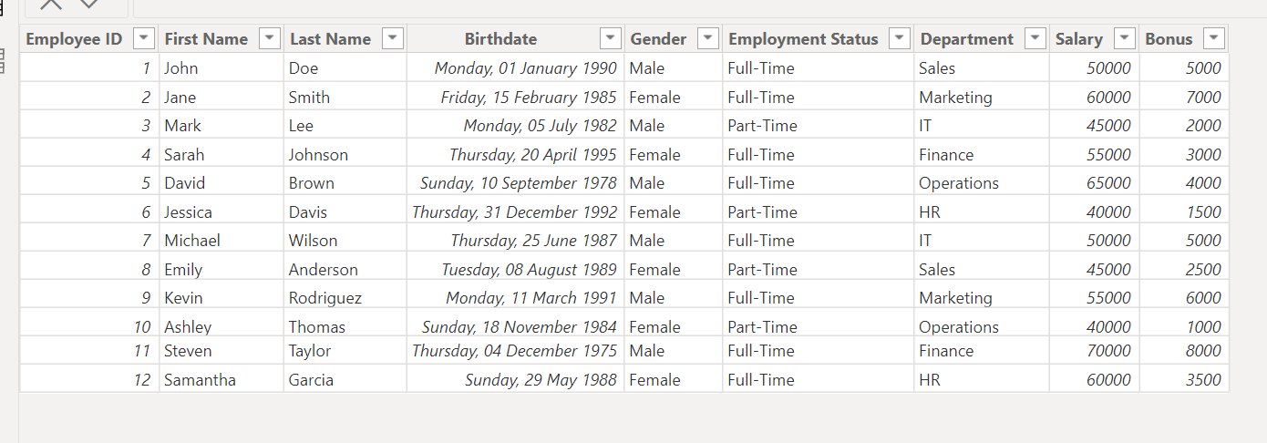

1. Create a new calculated column to calculate the employee's age using the "Birthdate" column.

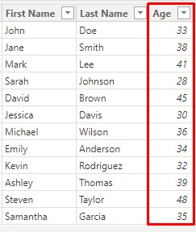

1. Create a new calculated column to classify employees as "Male" or "Female" based on their "Gender" column.

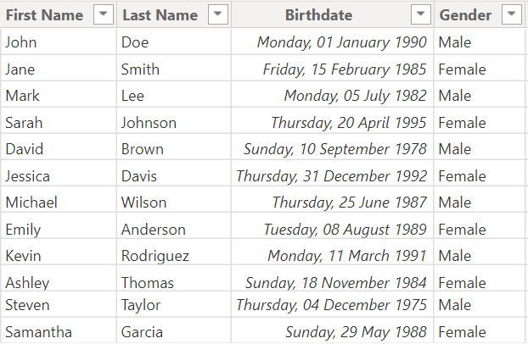

1. Create a new calculated column to classify employees as "Full-Time" or "Part-Time" based on their "Employment Status" column.

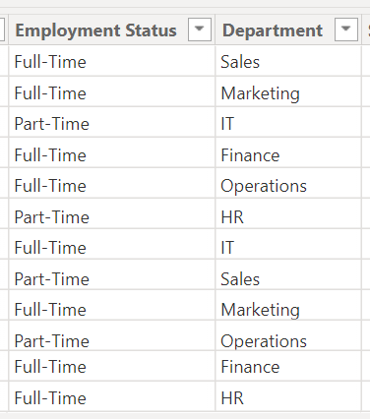

1. Create a new calculated column to calculate the total salary for each employee by adding their "Salary" and "Bonus" columns.

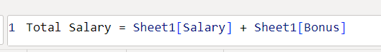

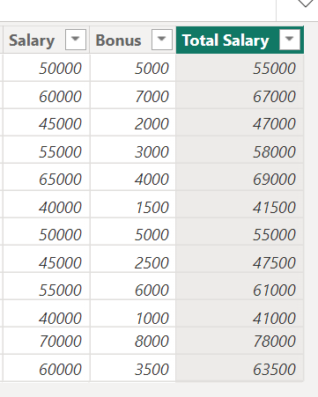

1. Create a new measure to calculate the average salary for each department.

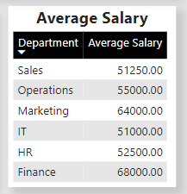

1. Create a new table to show the number of employees by department and by employment status.

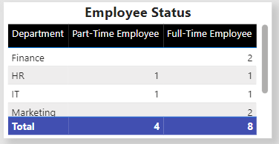

1. Create a new measure to calculate the total number of employees.

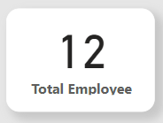

1. Create a new measure to calculate the total number of full-time employees.

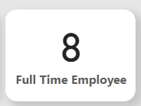

1. Create a new measure to calculate the total number of part-time employees.

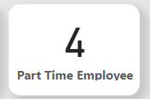

1. Create a new measure to calculate the total number of male employees.

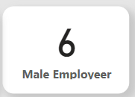

1. Create a new measure to calculate the total number of female employees.

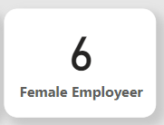

1. Create a new table to show the top 10 highest paid employees, including their name, department, and total salary.

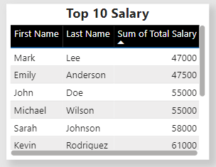

1. Create a new measure to calculate the total salary for each department and display it in a visual (e.g., a bar chart).

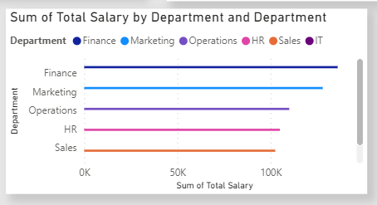

1. Create a new measure to calculate the total bonus for each department and display it in a visual (e.g., a bar chart).

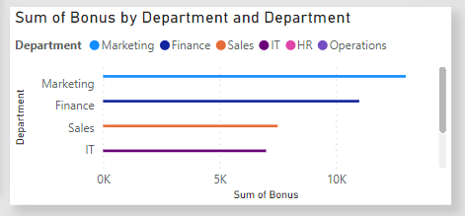

1. Create a new measure to calculate the total salary and bonus for each department and display it in a visual (e.g., a stacked bar chart).

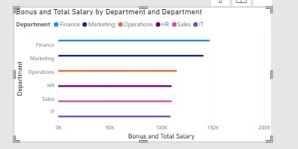

1. Create a new table to show the number of employees by age range (e.g., 20-30, 31-40, 41-50, etc.) and by employment status.

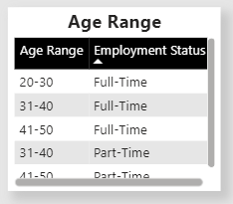

1. Create a new table to show the number of employees by gender and by employment status.

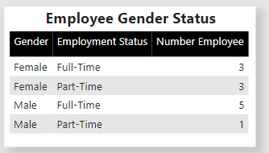

1. Create a new measure to calculate the average age of employees by department and display it in a visual (e.g., a column chart).

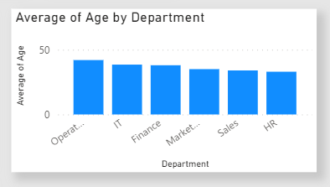

**The Final Result**

